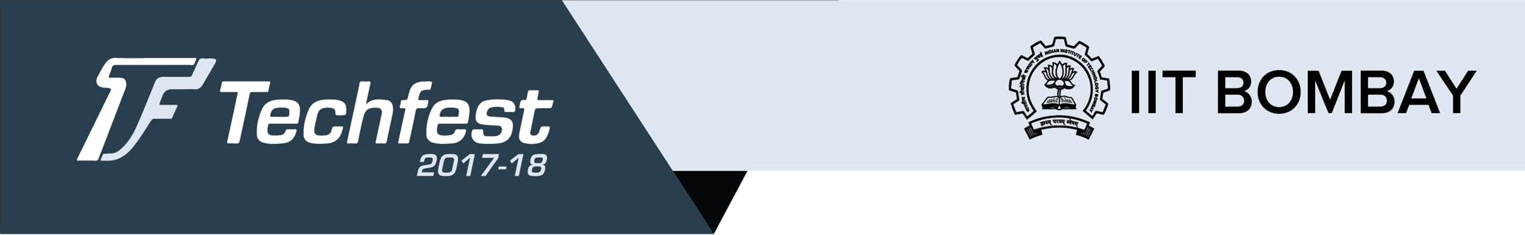

International Sustainability Challenge

“Sustainable Development requires human ingenuity. People are the most important resource.” -Dan Shechtman
Note:

- The following problem statements are just guidelines to help you. You are free to think like an unconventional thinker and come up with great innovations. So, do not limit yourselves to these problem statements.

- The projects should also be applicable in rural areas. The projects applicable in rural areas will be given more weightage.

Renewable Energy & Rural Economy

Background

Agriculture and allied sectors contribute approximately 18 percent to the GDP and constitute more than 50 percent of the labor force in India (World Factbook, 2015; Census 2011). Traditionally, agriculture has been labor intensive. However, the Green Revolution in 1960s, brought about a surge of mechanization in the farm sector, along with use of high-yielding varieties of seeds, fertilizers, and irrigation practices. Studies illustrate the benefits from improved mechanization are shared by all farmers of the state, irrespective of the size of their operational holdings ownership of the equipment. Farm mechanization has furthered agricultural production, and improved farmers’ incomes in developed countries. It has also improved labor productivity and reduced drudgery. Today, the overall farm mechanization in India is around 40-45 per cent, presenting immense scope for expansion.

The average farm power availability in India has increased from about 0.30 kW/ha in 1960-61 to about 2.02 kW/ha in 2013-14. However, this compares inadequately to that of Japan at 8.75 kW/ha. Energy is a critical input for mechanization and renewable energy today presents an opportunity to further mechanization in areas with little or no energy access, as well as an opportunity design fuel-free cost efficient green mechanization.

While agriculture might be contributing to rural livelihoods, it is the non-farm sector that has assumed a higher share in rural incomes during the present decade. Harnessing the value chain of rural income generating activities can create avenues for income locally. Access to renewable energy can remove one of the biggest bottlenecks to local production, thus enabling activities in rural areas and the periphery to create employment. Examples include agri-processing, spinning & weaving of textiles, pottery making, bamboo basket making, and numerous other ‘cottage’ industries.

Thus, the broad aims are:
- Supporting rural income generation
- Expand mechanization to support rural income generation
- Use renewable energy to power rural income generating activities
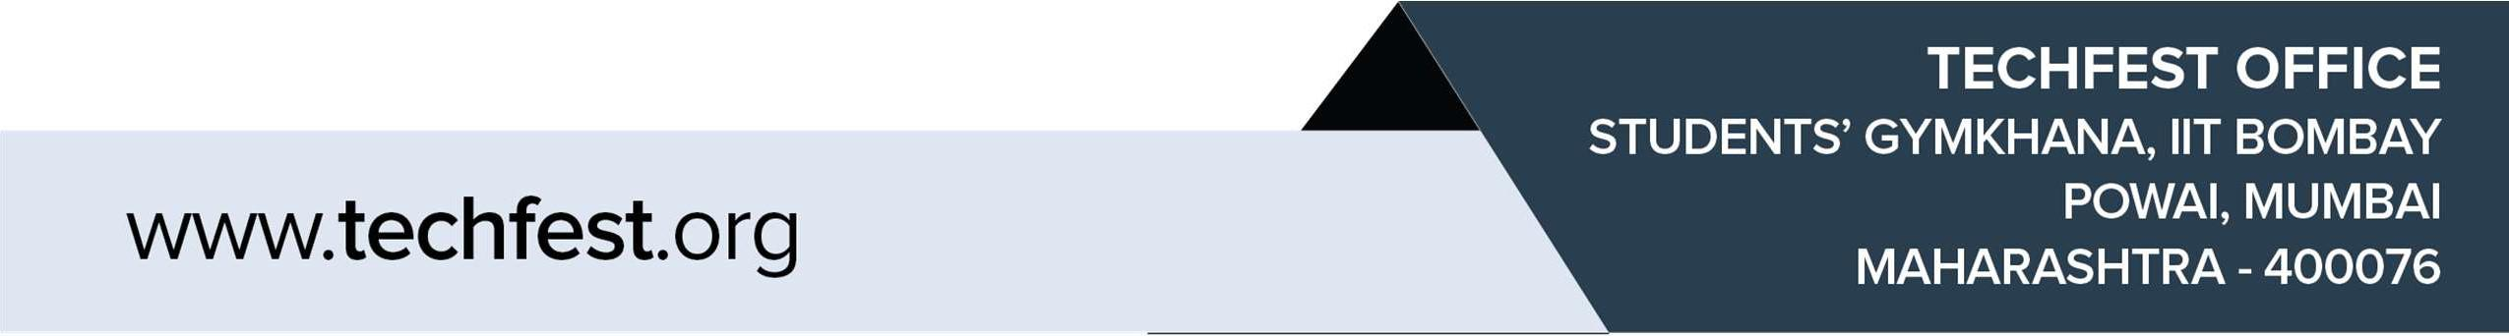

Problem statement

Track 1: Renewable Energy + Agriculture

The net income of the farmer is dependent on agricultural yields and input costs. Innovations need to be focused on lowering of input costs and increase in yield (resulting in increase in gross income) as the main value propositions. Beyond this, co-benefits include water savings, improved soil quality, food security, reduced drudgery, improved health &amp; sanitation, livelihood creation, improved quality of life, and gender equality among others. These are indicative, and bonus points will be awarded if the innovation results in a co-benefit.

Track 2: Renewable Energy + Rural Non-Farm Activities

The net income of the rural entrepreneur is dependent on productivity and input costs. Innovations need to be focused on lowering of input costs and increase in productivity (resulting in increase in gross income) as the main value propositions. Beyond this, co-benefits include reduced drudgery, improved health &amp; sanitation, livelihood creation, improved quality of life,

gender equality, and low-carbon economic growth among others. These are indicative, and bonus points will be awarded if the innovation results in a co-benefit.

Potential focus of innovations:-

- Throughout gain over existing process by improving upon the product design, resulting in improved yield or productivity

- Energy efficiency improvements by improving upon the product design, resulting in lowering of energy consumption (& therefore lowering of input costs)

- New product development that targets at least 1 co-benefit apart from the main value propositions.

- New business model innovation that targets at least 1 co-benefit apart from the main value propositions.

About CEEW:-

The Council on Energy, Environment and Water (http://www.ceew.in/) is one of South Asia’s leading not-for-profit policy research institutions. CEEW uses data, integrated analysis, and outreach to explain – and change – the use, reuse, and misuse of resources. It prides itself on the independence of its high quality research, develops partnerships with public and private institutions, and engages with wider public. In 2017, CEEW has once again been featured extensively across nine categories in the ‘2016 Global Go To Think Tank Index Report’. CEEW has also been consistently ranked amongst world's top climate think-tanks.

Evaluation

- Preliminary Stage

  - POC or working principle being clearly demonstrated on paper – mandatory

  - Business plan on paper – should include preliminary market sizing and basic prototyping cost estimates – mandatory

  - Having working prototype – optional

  - Unit cost of production numbers and NPV calculation – optional

- Final selection for Demo Day

  - Working prototype demonstrated at the final event – mandatory

  - Detailed pitch deck, where template can be provided by CEEW – mandatory

Eligibility

- Individuals or teams from the following categories are allowed:

  - Students/research scholars of authorised institutions (Students have to Show their Valid College ID).

  - Early stage startups OR upto 3 years old college passouts.
- A team is allowed to have maximum 4 members.

- If the participating team feels that their idea requires more participants in their team, they can forward their request, with suitable reasons, to sustainability@techfest.org with the subject "Ideate: Team number increase request".

Registration and Submission

The Participants have to register on the official Techfest Website and fill all the necessary details : www.techfest.org > Ideate > Explore More > sustainability > Register.

Abstract Submission:

Teams will be required to submit one report to sustainability@techfest.org . This report should contain the idea they are looking forward to work on.

Abstract Format

- Title

- Sectors
- Background and Research:
  - Present methods of tackling the problem (if any)
  - Limitations of present solutions.
  - Alternate approaches
  - Proposed Solution

  - Novelty of Approach: How is or will be your solution better than existing products and overcome previous limitations?

- Problems it solves and its Beneficiaries

- POC or working principle being clearly demonstrated on paper

- Business plan on paper – should include preliminary market sizing and basic prototyping cost estimates

7. Plan (with timeline) and current status

- Technical Details:
    - Technical aspect of the proposed solution.

    - Detailed technical specifications and Pictorial representations (block diagrams/ flow chart).

    - Description of the flow of operations demonstrating key features and functionality.

    - Performance estimate of the solution.
    - Experimentation done to establish the workability of the above.

- A link of the Google Drive Folder which contains Pictures and Video of the working model/ prototype.

- Results
  - Actual findings, significant output of tests and analysis (Must be readable)
  - Include problems encountered, credibility of results, accuracy estimates
  - Pros and cons of your solution
  - Utility of results

- Future prospects and research in it and further development (in brief)

Submission Format:

The project report should be emailed to sustainability@techfest.org with the subject Ideate: I.S.C Project Report: Team Id (For example Ideate: I.S.C: ST1234). Teams must follow the following details for the submission:

- The abstract must be submitted in pdf format only

- Font: Arial
- Size: 11
- Spacing between two lines: 6 pts
- Spacing between two paragraphs: 10 pts
- Bottom margin: 1 inch
SHORTLISTING

Top 20 teams will be selected and would get the chance to present their model/idea in the Final Round at Techfest, IIT Bombay which is from 29th-31st December, 2017. Participants will get a slot for presenting their model/idea to the Judges based on which they will be evaluated.

General Rules

- All projects being displayed will have a fair chance of receiving further development opportunities offered by funding organizations and Venture capitalists.

- Every team has to register online on our website for the competition. A Team ID will be allocated to the team on registration which shall be used for future references.

- A team can register at any point of time before 9th November 2017 and can submit final abstract and video (as mentioned in the structure).

- The decision of the organizers or judges shall be treated as final and binding on all. Techfest has all the rights to verify the identity and accuracy of the details provided by the participants.

- No responsibility will be held by Techfest, IIT Bombay for any late, lost or misdirected entries.

- The idea presented by the teams should be original (not protected by means of patent/copyright/technical publication by anyone).

- Note that at any point of time the latest information will be that which is on the website. However, registered participants will be informed through mail about any changes on the Website.

- All mode of official communication will be through the techfest e-mail.

International Participants

All international participants will have to register before 9th November 2017, and will have to submit the complete report along with video prototype before 9th November 2017. The shortlisted international teams’ details will be put up on the website by 27th November 2017.

Certificate policy

Only those teams that are shortlisted for the finals and also give a final presentation about their work during Techfest 2017-18 would be awarded a Certificate of Participation. The top entries from this event would be provided with Certificate of Excellence.

Timeline
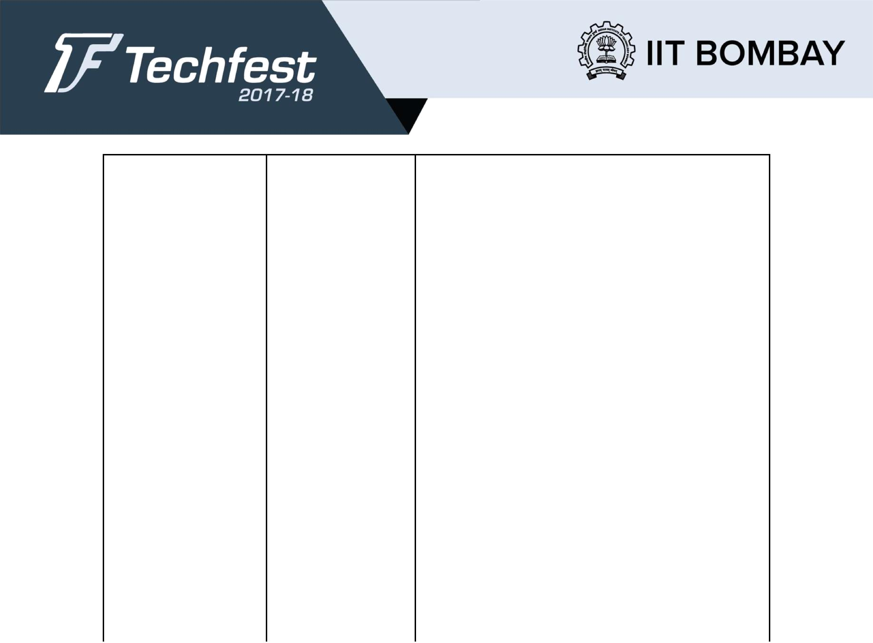

 | Last Date of |  | 9th November |  | Participants need to register before this date.
 | Registration | 2017
 | Final Project Report |  | 9th November |  | Submission of final project report along with
 | Submission | 2017 |  |  | video prototype (if any) has to be submitted
 |  |  |  |  | before this date.
 | Declaration of Result |  | 27th November |  | Declaration of shortlisted teams for final
 |  | 2017 |  |  | presentation at Techfest, IIT Bombay on the
 |  |  |  |  | basis of final report and the supporting materials.
 | Improvisation Stage |  | 27th November to |  | Shortlisted participants are to improve upon their
 |  |  | 14th December |  | model and prepare a presentation for the final
 |  | 2017 |  |  | round.
 | Final Presentation |  | 15th December |  | Participants have to submit the final video of
 | and Video | 2017 |  |  | prototype and presentation to be displayed
 | submission |  |  |  | during the festival before this date.
 | Presentation Stage |  | 29th-31st |  | Final presentation along with demonstration of
 |  |  | December 2017 |  | working prototype.

CERTIFICATE POLICY:

● Top three teams in the grand finale will be awarded Certificate of Excellence.

● E-Certificate of participation will be given to the teams scoring more than the critical marks which will be decided later.

Prizes:

The Prize money will be awarded to Winners via NEFT and will be processed within 20 working days after the receiving the Prize Money from Sponsors.
The Winner have to mail the following information (immediately after announcement of results) to prithviraj@techfest.org.
Subject: Compi Name, team id- your position (example- Vise Clutch, VI1003- 3rd Position)
Body of mail-
1.Account Holder’s Name
2.Account Number
3.Bank name and Branch name.
4.IFSC Code

